1️⃣ Why Connection Pooling is Needed
Creating a database connection is very expensive.
When a connection is created, several things happen:
- Network connection to database server
- Authentication
- Memory allocation
- Session creation inside DB
So this operation takes time and resources.
If a web application receives 1000 requests, and each request creates a new connection:
Request → create connection → execute query → close connection
Then the database server will be overloaded.
This reduces application performance.

2️⃣ Solution: Connection Pool
Connection Pool means:
Create a small number of connections once
Reuse them many times
Example:
Connection Pool Size = 10
At application startup:
10 connections created
stored in pool
When request comes:
Application borrows connection
After query execution:
Connection returned to pool
Then another request can reuse it.

Visual Flow
Application
↓
Connection Pool
↓
Database
Requests never directly create connections.
They borrow from the pool.

3️⃣ Advantages of Connection Pooling
1️⃣ Better Performance
Connections are reused instead of created repeatedly.

2️⃣ Reduced Database Load
Database handles fewer connection creations.

3️⃣ Faster Request Processing
Applications can serve requests faster.

4️⃣ HikariCP (Industry Standard)
Modern Java applications use HikariCP.
HikariCP is:
A high-performance JDBC connection pool library
It is known for:
- Very fast performance
- Low memory usage
- Stability
Because of this:
Spring Boot uses HikariCP by default
Example configuration in Spring Boot:
spring.datasource.hikari.maximum-pool-size=10
You normally do not write pooling code manually.
Framework handles it.

Modern projects use framework-managed pooling.

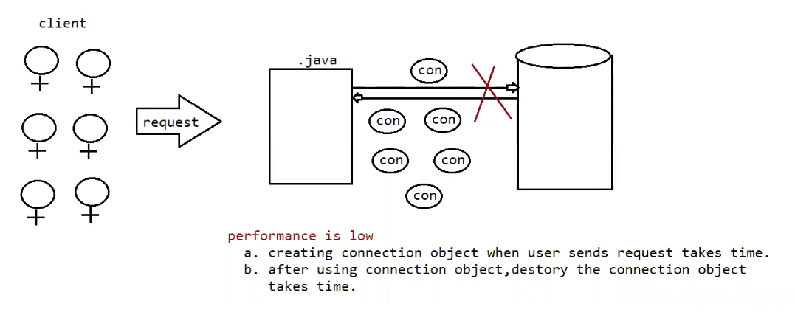

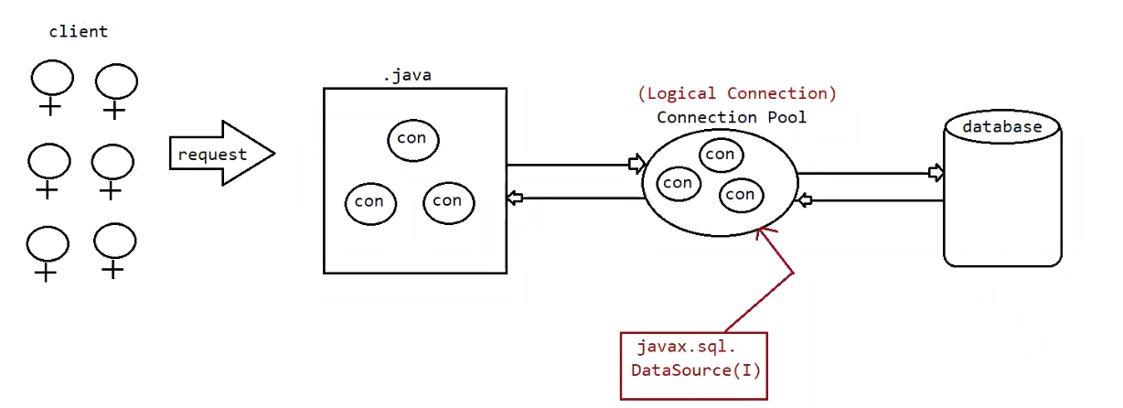

Eg: Pooled_Connection_Hickaricp

1️⃣ Default ResultSet (Forward Only)
By default, JDBC creates a Forward Only ResultSet.
Meaning:
Cursor moves only forward
Example:
Statement stmt = connection.createStatement();
ResultSet rs =
stmt.executeQuery("select * from student");
while(rs.next()){
System.out.println(rs.getString("name"));
}
Here:
rs.next()
moves only forward.
You cannot go backward.

2️⃣ Scrollable ResultSet
Scrollable ResultSet allows cursor to move anywhere.
To create it, we must specify ResultSet type.
Example:
Statement stmt = connection.createStatement(
ResultSet.TYPE_SCROLL_INSENSITIVE,
ResultSet.CONCUR_READ_ONLY
);
ResultSet rs =
stmt.executeQuery("select * from student");
Now cursor can move in different directions.
Example methods:
rs.first(); // move to first row
rs.last(); // move to last row
rs.absolute(3); // move to 3rd row
rs.relative(-1); // move one row backward
This is enough knowledge.

3️⃣ Sensitive vs Insensitive
These refer to whether database changes are reflected.
TYPE_SCROLL_INSENSITIVE
Database changes are not visible in ResultSet.
Example:
DB record updated after ResultSet created
ResultSet still shows old value

Eg: Scrollable_In_Sensitive_App

TYPE_SCROLL_SENSITIVE
Database changes are visible.
But this type is rarely used in real applications.

4️⃣ Updatable ResultSet (Just Idea)
Normally we update data using:
UPDATE SQL query
But JDBC also allows updating using ResultSet.
Example idea:
rs.updateString("name","Pavan");
rs.updateRow();
But in modern applications:
almost never used
Developers prefer SQL or ORM frameworks.
So just know it exists.

5️⃣ Final Recommendation (Exactly What You Need)
For ResultSet types, this is enough:
Know Concept
- Forward Only ResultSet
- Scrollable ResultSet
- Sensitive vs Insensitive
- Updatable ResultSet (idea only)
See One Small Example
Example creation:
Statement stmt = connection.createStatement(
ResultSet.TYPE_SCROLL_INSENSITIVE,
ResultSet.CONCUR_READ_ONLY
);
And cursor movement:
rs.first()
rs.last()
rs.absolute()
rs.relative()

